Wallhaven.cc's Alpha Stage Testing

# Leart Doko

# CS 1699 – FINAL DELIVERABLE

## Summary

Around September one of the biggest wallpaper providing websites knows as Wallbase.cc closed down for unknown reasons. The web developers of that website, who were not the owners, managed to scavenge some code and decided to start anew under the name of Wallhaven.cc.

I used to use Wallbase.cc a lot in order to find new wallpapers to give my laptop some flourish, and once I saw that Wallhaven.cc is currently under Alpha testing stage, I thought it would be a good idea to test various features of the website. Specifically, since I was dealing with a web medium I decided to use Web testing using the Selenium IDE in conjunction with the Behave implementation of Cucumber for Python. This allowed me to automate testing for features such as uploading, downloading, scrolling, favoring and logging in. Additionally, since the website has some other less straightforward features regarding its UI, I followed up with Usability testing, which covered some of the features more in depth: logging in, uploading, filtering and tagging.

## Issues

In the Web testing part I had some issues with developing tests for downloading, uploading and scrolling. One thing I did not realize when trying to develop these tests is that downloading and uploading are handled by the Operating System and not by the browser. As such, the Selenium IDE had no control over the selection of files, or save-as mechanisms. Additionally as I researched further in, I discovered that testing file upload and download operations is generally costly (possibly catastrophic e.g. accidentally infinitely looping and uploading thousands of images) and can be done in a simpler and more sensible way: for downloading just follow up the file link in the website, and check if it loads i.e.e if the HTTP header returns an OK; and for uploading checking that the access is sequestered between users and non-users (or rather not logged in users) is also a good compromise. For scrolling I had to abstract a third layer, beyond using Python to use Selenium, by additionally using Selenium to run Javascript scripts which allowed me to test that feature.

There weren't any issues in covering Usability testing. I followed usability testing from usability.gov and drupal.org. Conducting the interviews and observing neutrally was a bit difficult, since I had to stop the urge of helping the volunteers in doing the tasks quickly or optimally.

In the future I would like to run combinatorial tests on the wallpaper filtering system so that I could cover it fully. Additionally, I would like to do a larger scale usability test so that a higher percentage of possible errors could be covered.

# Assessment

1. Problem Areas:

* Users had trouble with the interface of the filtering system.
* Users had trouble with the interface for adding tags when uploading images.

1. Issues:
   1. Red Issues: None
   2. Yellow Issues: UI Issues
      * The pre-highlighted tabs in the filtering mechanism aren't clear to first time users. They misconstrue color highlights for just color choices.
      * The add tags interface is needlessly complicated. Users were confused whether they were choosing categories or tagging. Also the tagging system was not visually responsive enough for the users to feel like their choices are going through.
   3. Green Issues:
      * Small bug would appear where the number of uploaded pictures in the users profile would take a while to update.
2. Overall assessment
   * + All major features tested are a-go. Downloading, uploading, searching, favoring, logging in and dynamic scrolling. The system is well on its way to Beta stage testing.
3. Recommendation for release
   * + In light of the UI issues that users faced I would recommend a slight redesign of the filtering and tagging UI. Specifically, the redesign should try to be more clear and responsive towards the users actions. Following further usability testing after that, and regression tests to make sure that all functions and features are a-go then I would recommend the system for widespread release.

Website under test: <http://alpha.wallhaven.cc/>

Testing Code and Files (private repository): <https://github.com/leartd/testing-wallhaven>

# Web Testing

Feature and Step files can be found in the Repository. Screen shots in the next few pages.

## Usability Testing

Two interviews were conducted on volunteers in regards to UI features of Wallhaven.cc. The features were tested under a task-based system while the interviewees spoke their thoughts out loud. Below you will find the interview guideline designed and used to test these features: uploading, filtering, tagging, logging in and out. The interview audio and transcripts are found in the Usability folder in the repository. Additionally, screen shots of problem areas and descriptions of those problems will follow the guideline.

### Usability Test of Wallhaven.cc: Moderator Guideline

Thank you for agreeing to take part on this test. To be clear, we will only be testing the website, so you don't have to worry about your performance. Take as little or as long as you need to go through the tasks.

Additionally, this test will be audio recorded. Do I have your permission to do so? Thank you.

Pre-task survey:

You will be testing a wallpaper website. Knowing that, what are you expecting?

Tasks:

­ First task: Go to the Latest Upload page.

Second task: Show only images that are Safe for Work with an 16:9 aspect.

Third task: Sort the images by views and ascending order.

Fourth task: Now please login with the following credentials: user name “cs1699” and password “arctic”

Fifth task: Now try to upload one of the images from the folder that is open to you and tag it.

Sixth task: Find your uploaded pictures.

Seventh task: Now try to find the categories of tags page.

Seventh task: Log out.

After tasks survey:

Now that you've experienced the system, what do you think of it?

What did you find easy? What did you find hard or confusing? Why?

What would you suggest as an added feature? What should we remove?

Thank you once more for your time.

### Screen shots and Issues

Default filter state

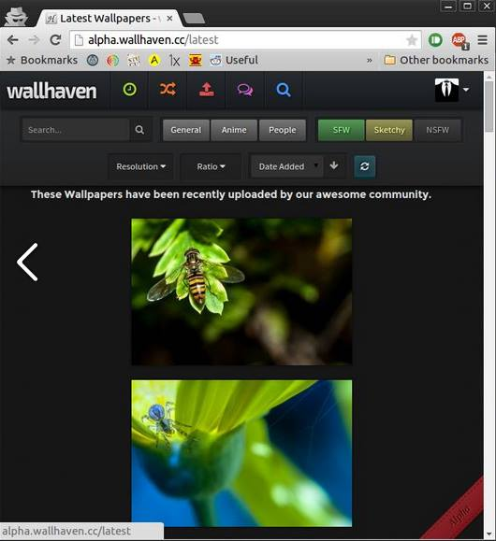

When the user tried to select the SFW option to filter his choices, what happened was that he deselected that option. As in the following image, where the option is not colorful anymore. The users were baffled at first, and then they “got the hang of it.” However this should perhaps be even clearer for future first time users.

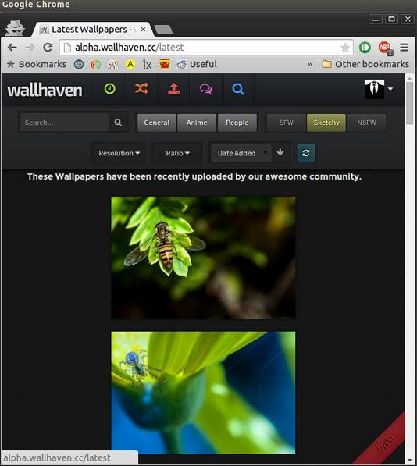

The tagging mechanism on the other hand is presented thus.

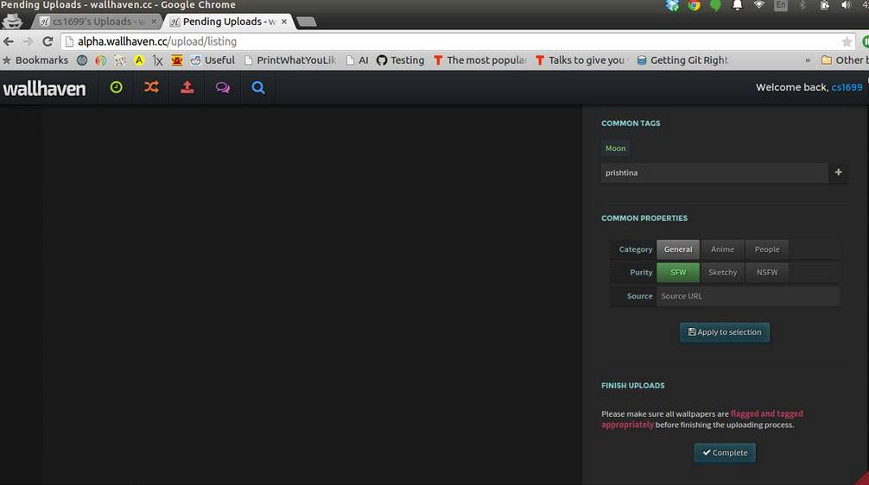

And when the user tries to add a simple tag, then they are requested to go through a number of steps which included choosing categories and more specific categories, in addition to aliases. While this is useful from a developer's perspective, the users found it over complicated.

